Assignment on

Python Programming

Nаmе: Abhijit Goenka

Roll no.: R252222003

Sаp ID: 500106633

Course: B.C.A AIML Batch 1



School of Computеr Sciеncе

University of Petroleum and Еnеrgy Studies

Dehradun

**1.Python Program to Print Hello world.**

print('Hello, world!')

output:



**2.Python program to add two numbers.**

num1 = float(input("Enter the first number: "))

num2 = float(input("Enter the second number: "))

sum = num1 + num2

print("The sum of", num1, "and", num2, "is", sum)

output:

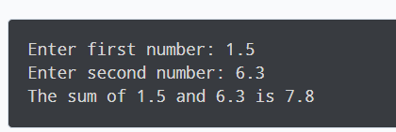

3.**Program to generate a random number between 0 and 9**

import random

print(random.randint(0,9))

output:



**4. Python program to check if the input number is odd or even.**

num = int(input("Enter a number: "))

if num % 2 == 0:

print(num, "is an even number.")

else:

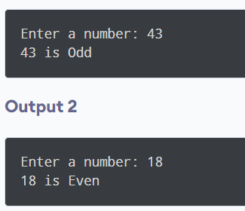print(num, "is an odd number.")

**5. Python program to check if year is a leap year or not**

year = int(input("Enter a year: "))

if (year % 4 == 0 and year % 100 != 0) or (year % 400 == 0):

print(year, "is a leap year.")

else:

 print(year, "is not a leap year.")

**6.To check if a number is prime or not.**

num = int(input("Enter a number: "))

if num > 1:

is_prime = True

for i in range(2, int(num**0.5) + 1):

if num % i == 0:

is_prime = False

break

if is_prime:

print(num, "is a prime number.")

else:

print(num, "is not a prime number.")

else:

print(num, "is not a prime number.")

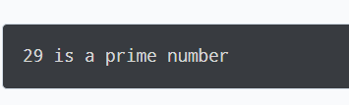

**7.To find factorial of a number provided by the user.**

num = int(input("Enter a number: "))

factorial = 1

if num < 0:

print("Factorial does not exist for negative numbers.")

elif num == 0:

print("The factorial of 0 is 1.")

else:

for i in range(1, num + 1):

factorial *= i

print("The factorial of", num, "is", factorial)



**8.To find largest number among the three input numbers.**

num1 = float(input())

num2 = float(input())

num3 = float(input())

if (num1 >= num2) and (num1 >= num3):

largest = num1

elif (num2 >= num1) and (num2 >= num3):

largest = num2

else:

largest = num3

print(“The largest number is”,num)



9.

import numpy as np

arr = np.array([1, 2, 3, 4, 5])

print(arr)

print(type(arr))

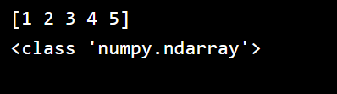

10.

import numpy as np

arr = np.array([1, 2, 3, 4, 5, 6, 7])

print(arr[1:5])

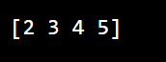

11.

import numpy as np

arr = np.array([[1, 2, 3, 4], [5, 6, 7, 8]])

print(arr.shape)



12.

import numpy as np

arr = np.array([1, 2, 3, 4, 5, 6, 7, 8, 9, 10, 11, 12])

newarr = arr.reshape(4, 3)

print(newarr)

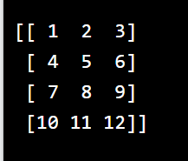

13.

import numpy as np

arr = np.array([1, 2, 3, 4, 5, 4,4])x=np.where(arr == 4)

print(x)

**14. Sort the array:**

import numpy as np

arr = np.array([3, 2, 0, 1])

print(np.sort(arr))

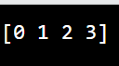

**15.Create an array from the elements on index 0 and 2:**

import numpy as np

arr = np.array([41, 42, 43, 44]) x = [True, False, True, False] newarr =arr[x]

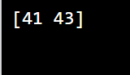print(newarr)

Output:

**16.Create a simple Pandas Series from a list:**

import pandas as pd

a = [1, 7, 2]

myvar = pd.Series(a) print(myvar)

Output:

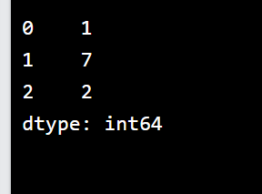

**17.Create a simple Pandas DataFrame:**

import pandas as pd

data = {

"calories": [420, 380, 390],

"duration": [50, 40, 45]

}

#load data into a DataFrame object: df = pd.DataFrame(data)

print(df)

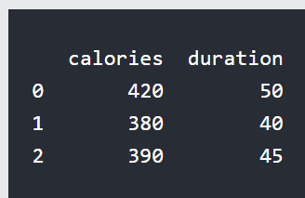

**18.Print the DataFrame without the to_string() method:**

import pandas as pd

df = pd.read_csv('data.csv') print(df)

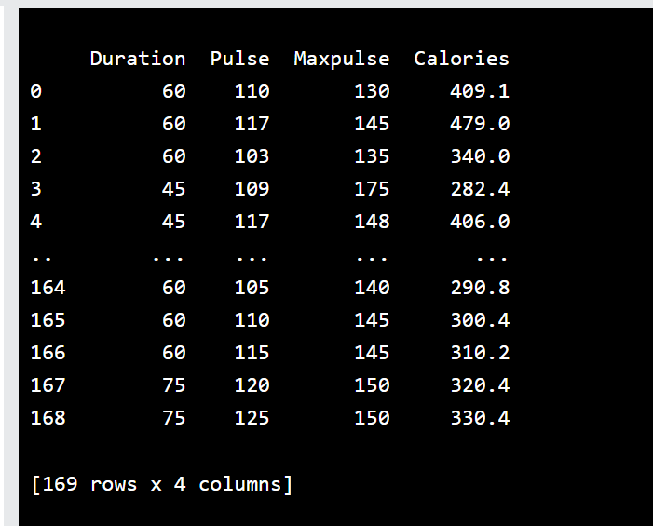

**19.Draw 4 bars:**

import matplotlib.pyplot as plt import numpy as np

x = np.array(["A", "B", "C", "D"])

y = np.array([3, 8, 1, 10])

plt.bar(x,y) plt.show()

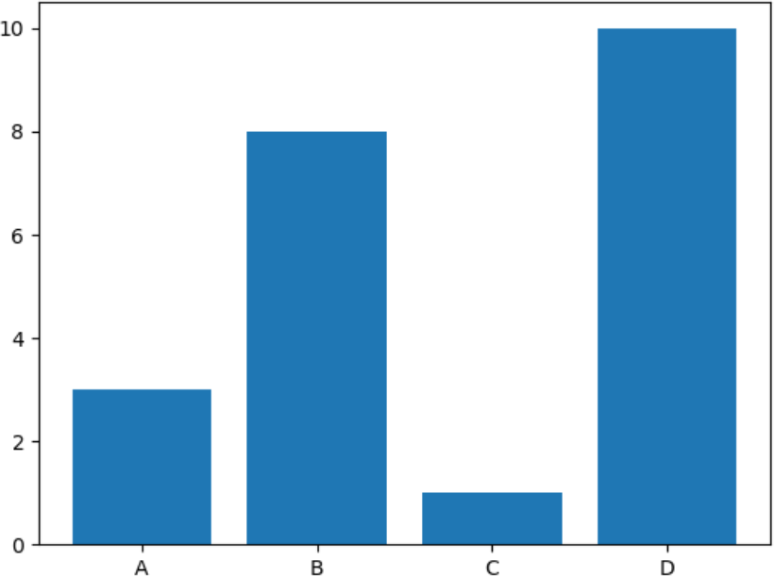

**20.A simple histogram:**

import matplotlib.pyplot as plt

import numpy as np

x = np.random.normal(170, 10, 250)

plt.hist(x)

plt.show()

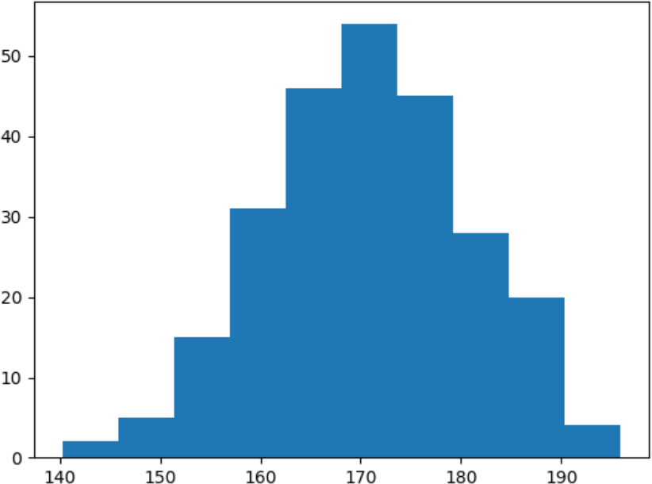

**21. A simple pie chart:**

import matplotlib.pyplot as plt

import numpy as np

y = np.array([35, 25, 25, 15]) plt.pie(y)

